

|  |  |  |  |
| --- | --- | --- | --- |
| **S.NO** | **name** | **reg.no** | **rOLLno** |
| **1.** | **jada sUjan kumar** | **11808434** | **16** |
| **2.** | **J.MANOJ REDDY** | **11809061** | **06** |
| **3.** | **Maruthi manohar** | **11814953** | **27** |
| **4.** | **Sarampally sandeep** | **11808367** | **25** |

**Submitted to:- Shabnam Mam**

**GITHUB_lINK:-** <https://github.com/sujan381/A-Simple-AI-Game>

**CONTEXT**

1. **introduction**
2. **Game rules**
3. **code**
4. **code screenshots**
5. **output sCREENSHOTS**
6. **github repository**
7. **Algorithm**
8. **conclusion**

**INTRODUCTION**

Our Project is on developing a simple AI game and we have decided to develop a snake and ladders game.Many of us know children likes snake and ladders a lot to get rid of their leiuser time.The game mainly consists of a set of rules which deceide the game winner.

**GAME** **RULES**:-

**The main Rules of the game are:-**

1. The game is played between two members only.
2. Both the players start their game from intial value which is “0”.
3. One player will roll the dice one by pressing “Enter” from the keyboard
4. The player climbs to the head of the ladder if he lands at the bottom of the ladder.
5. The player comes down to the tale of the snake if he lands on the head of the snake.
6. The person who will come first at “100” will be the winner of the game.
7. This game will end if any one comes to “100” spot.

**REGULAR** **GAME:-**

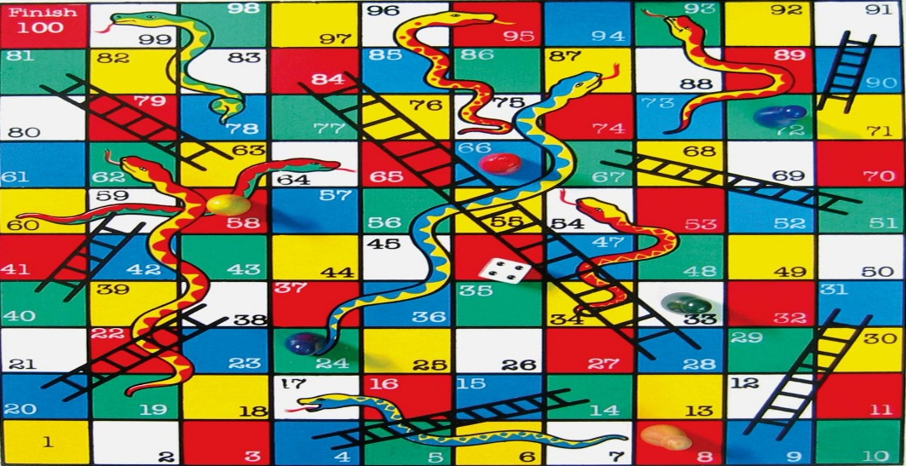

**CODE** :-

import time

import random

import sys

# just of effects. add a delay of 1 second before performing any action

SLEEP_BETWEEN_ACTIONS = 1

MAX_VAL = 100

DICE_FACE = 6

# snake takes you down from 'key' to 'value'

snakes = {

8: 4,

18: 1,

26: 10,

39: 5,

51: 6,

54: 36,

56: 1,

60: 23,

75: 28,

83: 45,

85: 59,

90: 48,

92: 25,

97: 87,

99: 63

}

# ladder takes you up from 'key' to 'value'

ladders = {

3: 20,

6: 14,

11: 28,

15: 34,

17: 74,

22: 37,

38: 59,

49: 67,

57: 76,

61: 78,

73: 86,

81: 98,

88: 91

}

player_turn_text = [

"Your turn.",

"Go.",

"Please proceed.",

"Lets win this.",

"Are you ready?",

"",

]

snake_bite = [

"boohoo",

"bummer",

"snake bite",

"oh no",

"dang"

]

ladder_jump = [

"woohoo",

"woww",

"nailed it",

"oh my God...",

"yaayyy"

]

def welcome_msg():

msg = """

Welcome to Snake and Ladder Game.

Version: 1.0.0

Developed by: JADA SUJAN KUMAR,ROLLNO:16,REG_NO:11808434

Rules:

1. Initally both the players are at starting position i.e. 0.

Take it in turns to roll the dice.

Move forward the number of spaces shown on the dice.

2. If you lands at the bottom of a ladder, you can move up to the top of the ladder.

3. If you lands on the head of a snake, you must slide down to the bottom of the snake.

4. The first player to get to the FINAL position is the winner.

5. Hit enter to roll the dice.

"""

print(msg)

def get_player_names():

player1_name = None

while not player1_name:

player1_name = input("Please enter a valid name for first player: ").strip()

player2_name = None

while not player2_name:

player2_name = input("Please enter a valid name for second player: ").strip()

print("\nMatch will be played between '" + player1_name + "' and '" + player2_name + "'\n")

return player1_name, player2_name

def get_dice_value():

time.sleep(SLEEP_BETWEEN_ACTIONS)

dice_value = random.randint(1, DICE_FACE)

print("Its a " + str(dice_value))

return dice_value

def got_snake_bite(old_value, current_value, player_name):

print("\n" + random.choice(snake_bite).upper() + " ~~~~~~~~>")

print("\n" + player_name + " got a snake bite. Down from " + str(old_value) + " to " + str(current_value))

def got_ladder_jump(old_value, current_value, player_name):

print("\n" + random.choice(ladder_jump).upper() + " ########")

print("\n" + player_name + " climbed the ladder from " + str(old_value) + " to " + str(current_value))

def snake_ladder(player_name, current_value, dice_value):

time.sleep(SLEEP_BETWEEN_ACTIONS)

old_value = current_value

current_value = current_value + dice_value

if current_value > MAX_VAL:

print("You need " + str(MAX_VAL - old_value) + " to win this game. Keep trying.")

return old_value

print("\n" + player_name + " moved from " + str(old_value) + " to " + str(current_value))

if current_value in snakes:

final_value = snakes.get(current_value)

got_snake_bite(current_value, final_value, player_name)

elif current_value in ladders:

final_value = ladders.get(current_value)

got_ladder_jump(current_value, final_value, player_name)

else:

final_value = current_value

return final_value

def check_win(player_name, position):

time.sleep(SLEEP_BETWEEN_ACTIONS)

if MAX_VAL == position:

print("\n\n\nThats it.\n\n" + player_name + " won the game.")

print("Congratulations " + player_name)

print("\nThank you for playing the game.\n\n")

sys.exit(1)

def start():

welcome_msg()

time.sleep(SLEEP_BETWEEN_ACTIONS)

player1_name, player2_name = get_player_names()

time.sleep(SLEEP_BETWEEN_ACTIONS)

player1_current_position = 0

player2_current_position = 0

while True:

time.sleep(SLEEP_BETWEEN_ACTIONS)

input_1 = input("\n" + player1_name + ": " + random.choice(player_turn_text) + " Hit the enter to roll dice: ")

print("\nRolling dice...")

dice_value = get_dice_value()

time.sleep(SLEEP_BETWEEN_ACTIONS)

print(player1_name + " moving....")

player1_current_position = snake_ladder(player1_name, player1_current_position, dice_value)

check_win(player1_name, player1_current_position)

input_2 = input("\n" + player2_name + ": " + random.choice(player_turn_text) + " Hit the enter to roll dice: ")

print("\nRolling dice...")

dice_value = get_dice_value()

time.sleep(SLEEP_BETWEEN_ACTIONS)

print(player2_name + " moving....")

player2_current_position = snake_ladder(player2_name, player2_current_position, dice_value)

check_win(player2_name, player2_current_position)

if __name__ == "__main__":

start()

**CODE SCREENSHOTS:-**

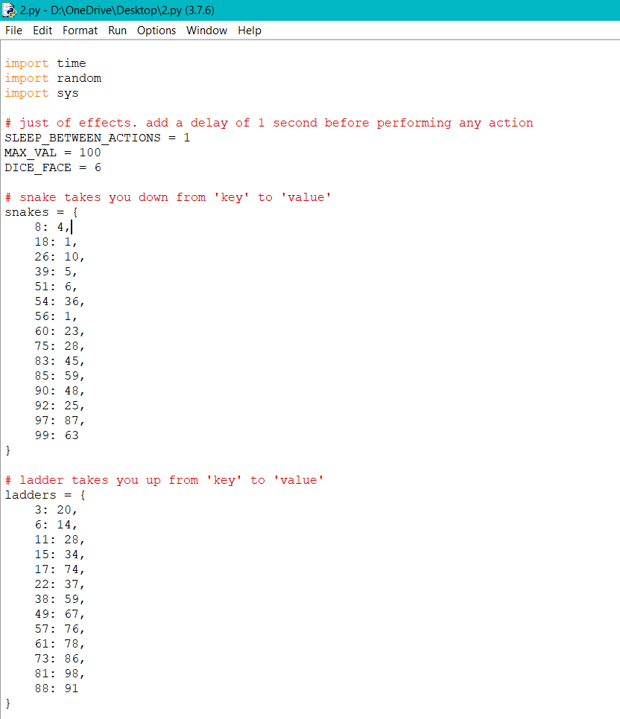

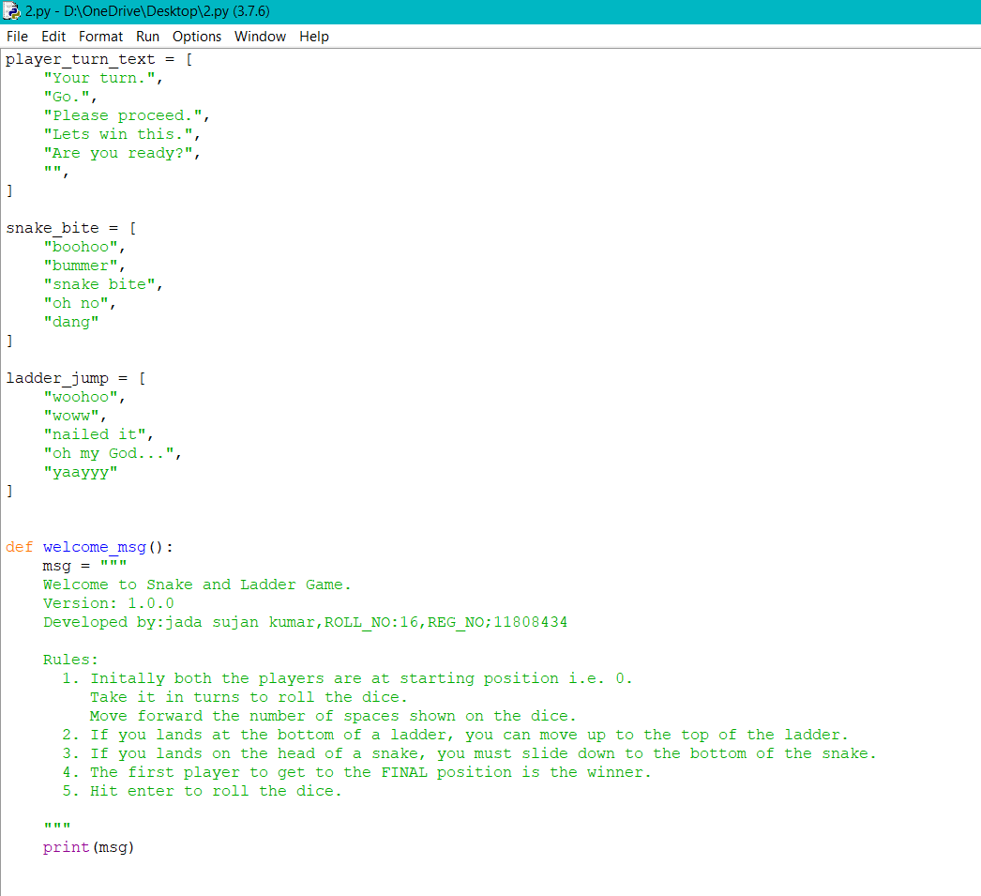

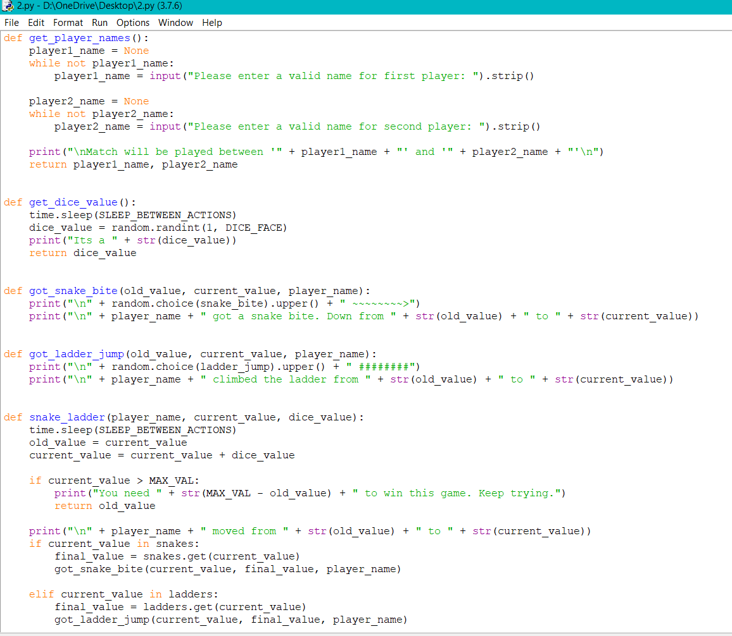

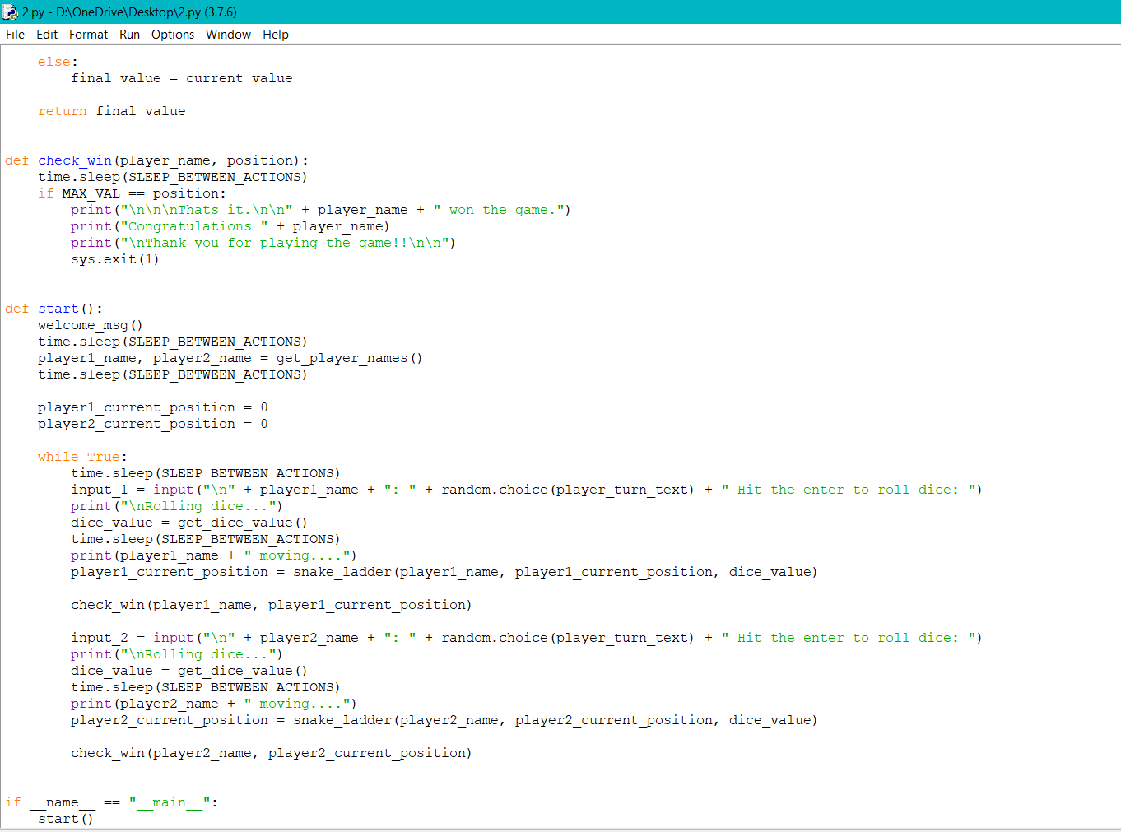

**OUTPUT SCREENSHOTS:-**

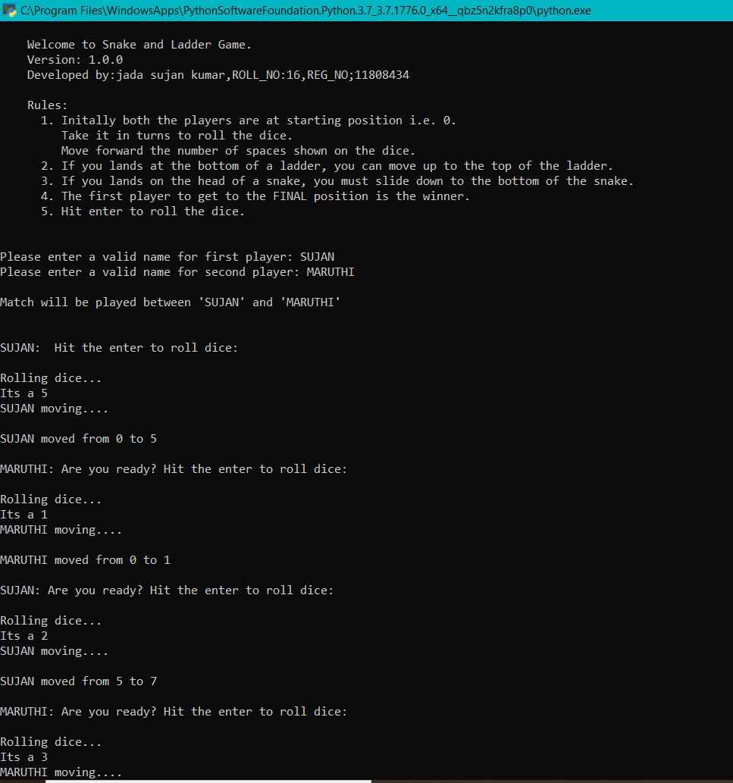

**GITHHUB REPOSITORY**

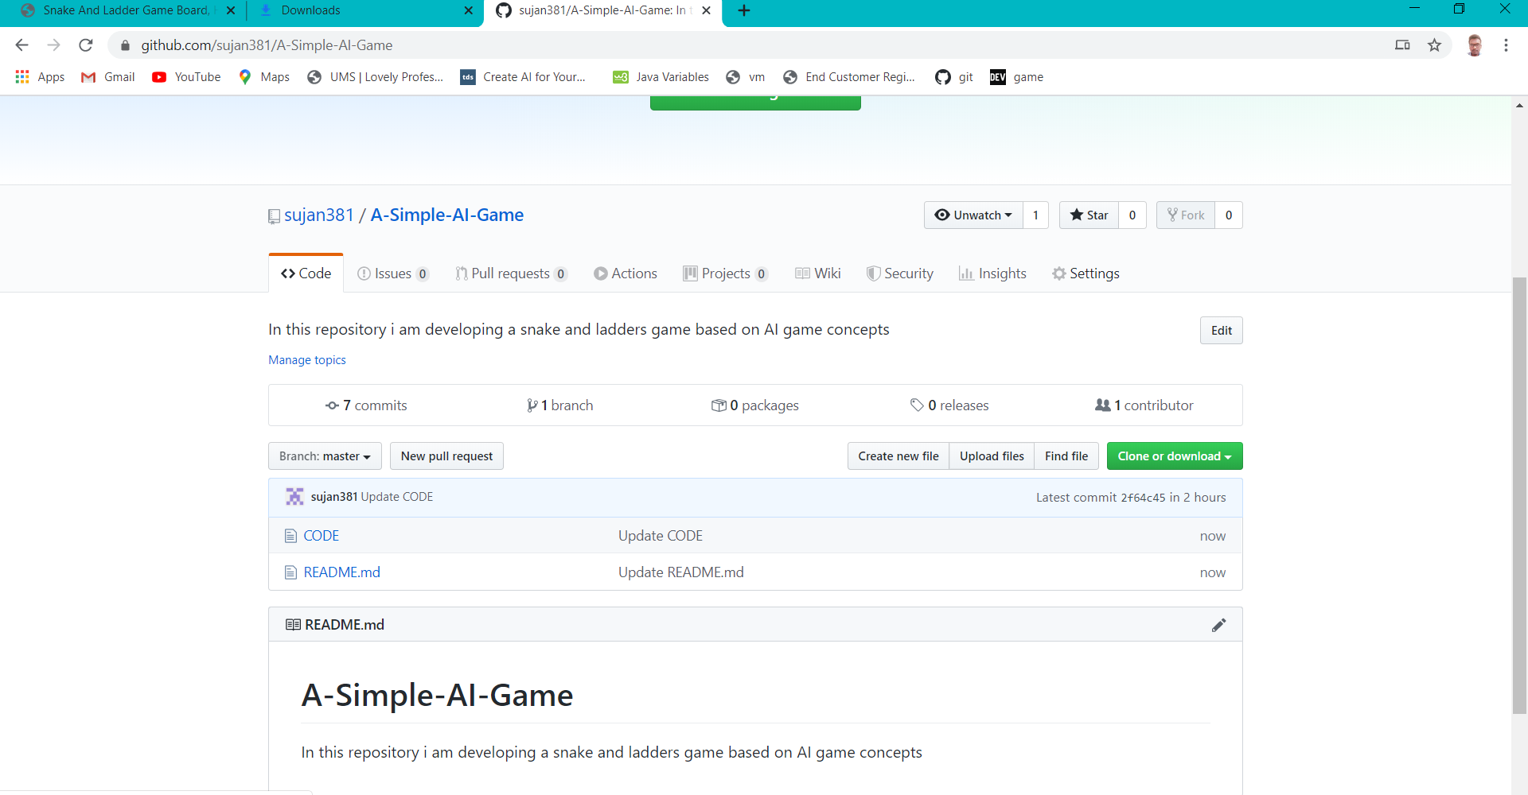

Link:- <https://github.com/sujan381/A-Simple-AI-Game>

**ALGORITHM:-**

The algorithm for the playing of game is given below:-

1.Enter the names of two players.

2.Press “Enter” to roll a dice

3.The player will be forwaded according to the output of the dice.

4.After one player another player will roll the dice and this process continues till he falls at bottom of ladder or head of the snake or he comes to “100” position.

5.If the palyer falls at bottom of ladder the player will climbs the ladder.

6.If the player falls on the head of the snake the player will be dragged to the tale of snake.

7.The player who will reach “100” position is the winner and the game Ends after this.

**CONCLUSION**

This is developed for the Ai project under the guidance of Shabnam mam.

Snakes In the Game Present At and the place it will take it is shown bellow:-

8: 4,

18: 1,

26: 10,

39: 5,

51: 6,

54: 36,

56: 1,

60: 23,

75: 28,

83: 45,

85: 59,

90: 48,

92: 25,

97: 87,

99: 63

The ladders present in the game and where it will take it to is given bellow:-

3: 20,

6: 14,

11: 28,

15: 34,

17: 74,

22: 37,

38: 59,

49: 67,

57: 76,

61: 78,

73: 86,

81: 98,

88: 91

**….The end….**